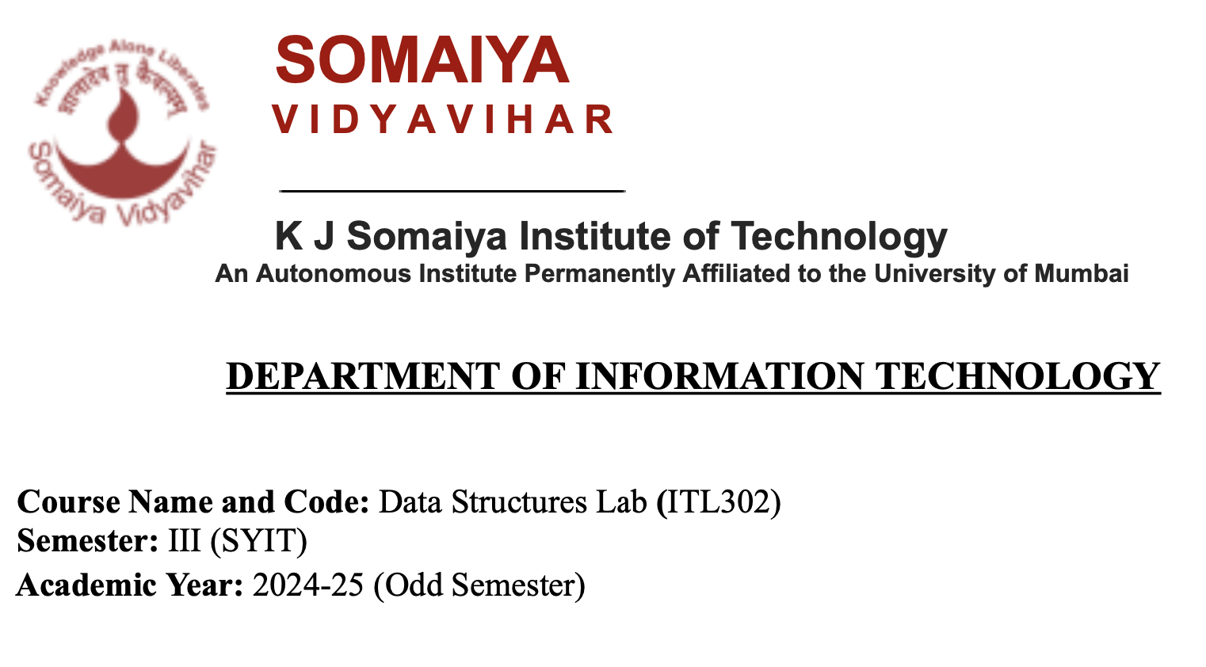

**Experiment NO.5**

**Aim:**Implementation of Singly Linked List / Circular Singly Linked List and various operations for real-world.

**Code:**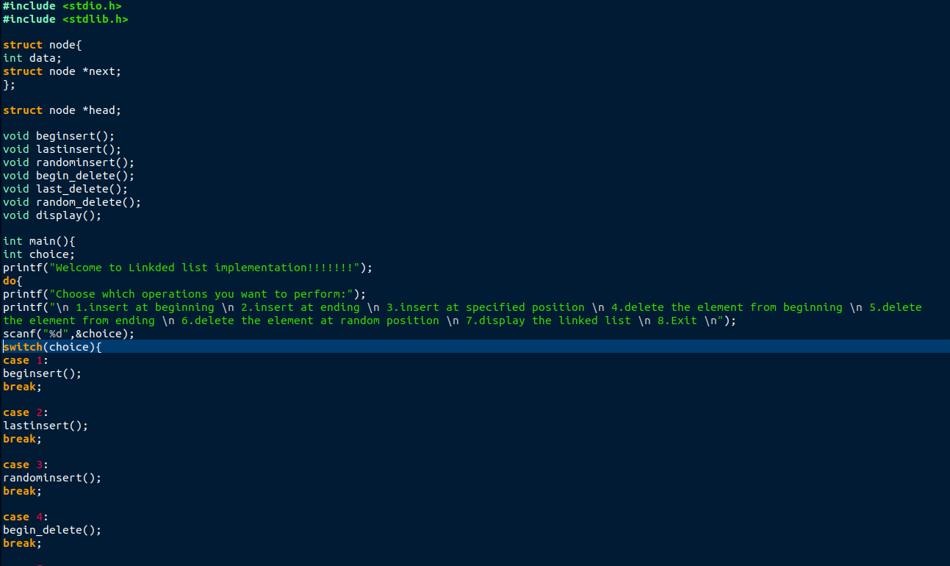

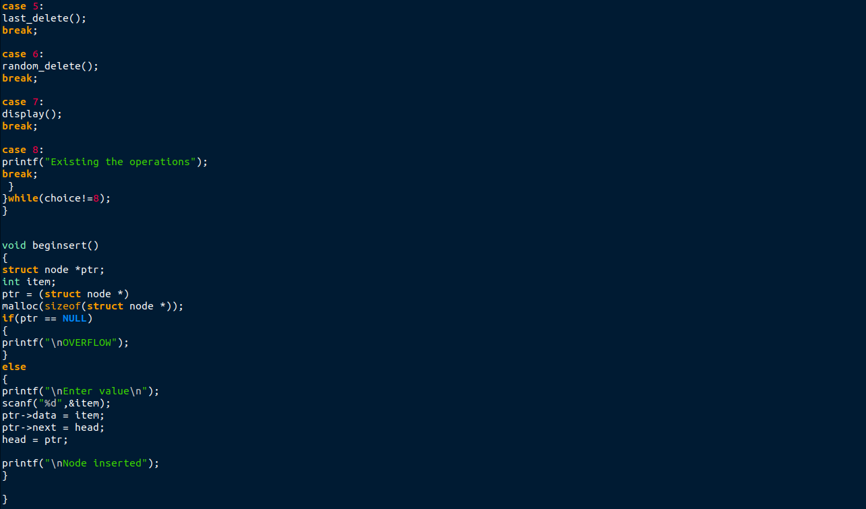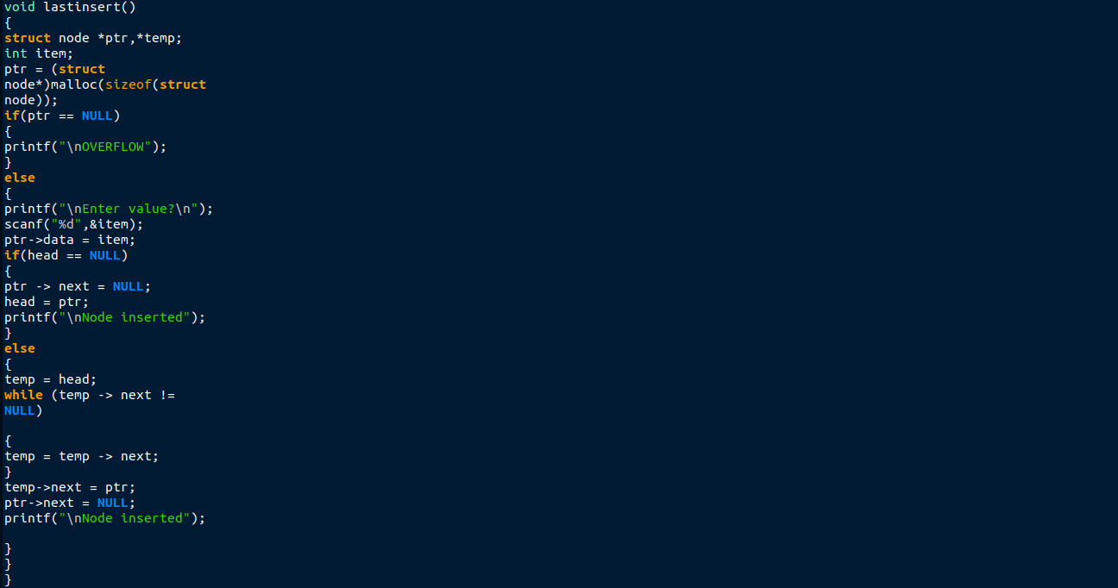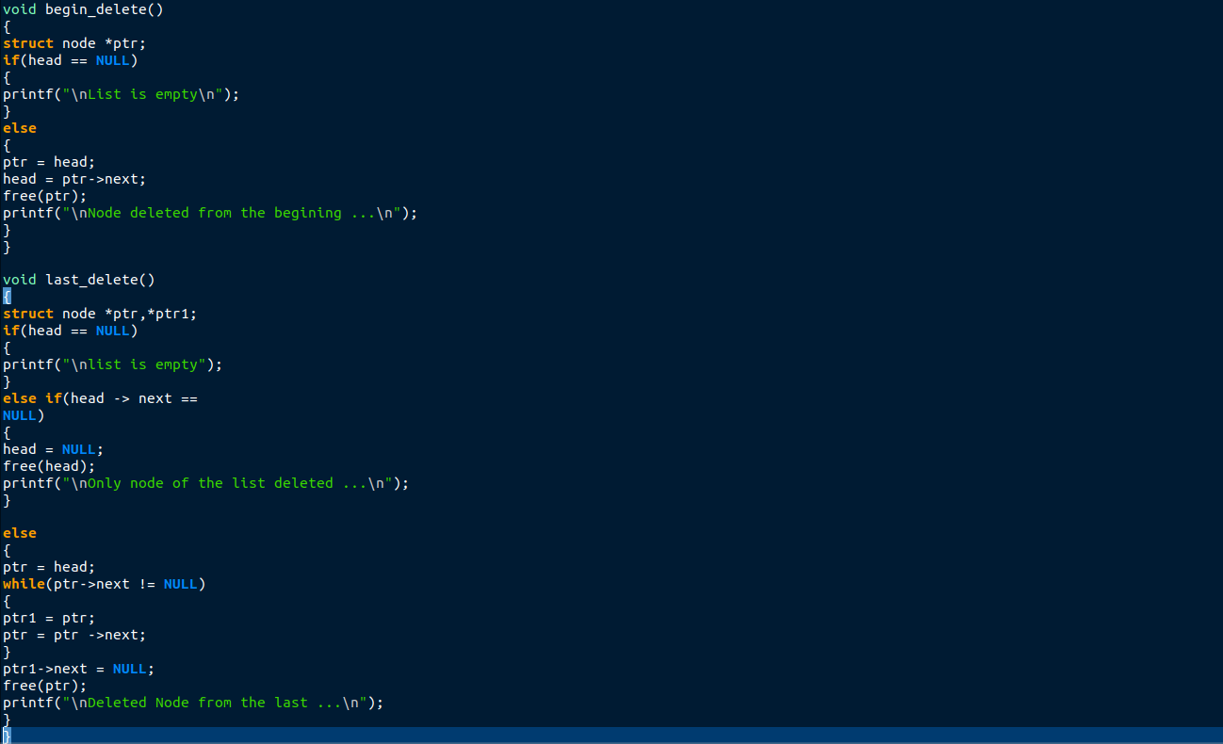

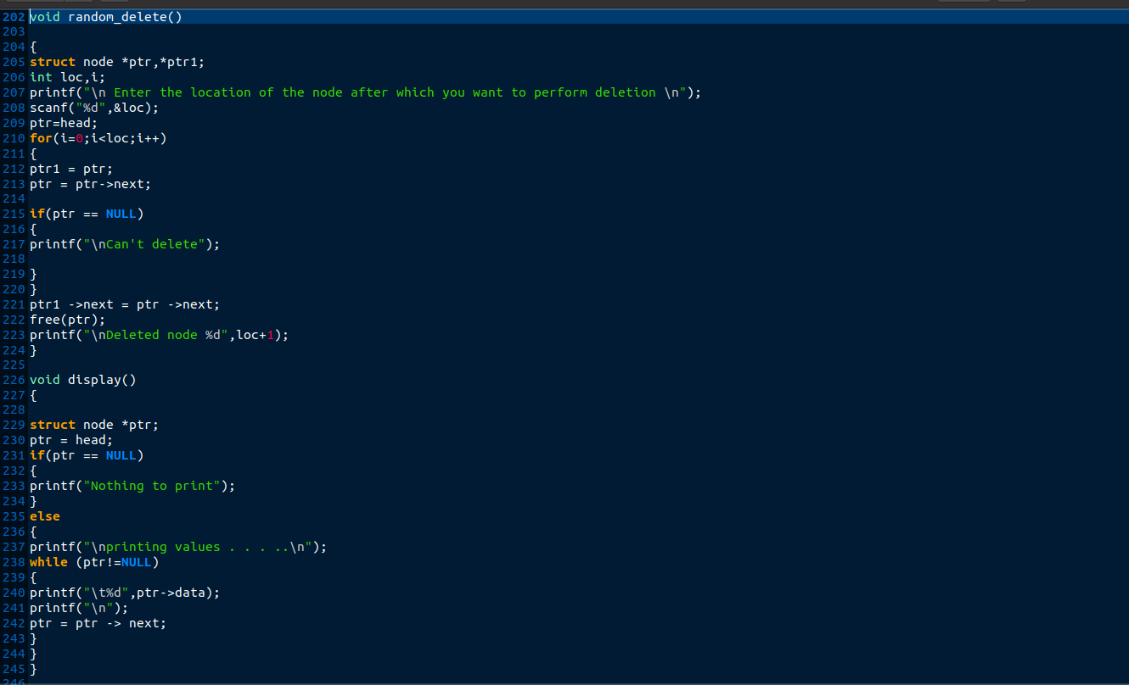

**Output:**

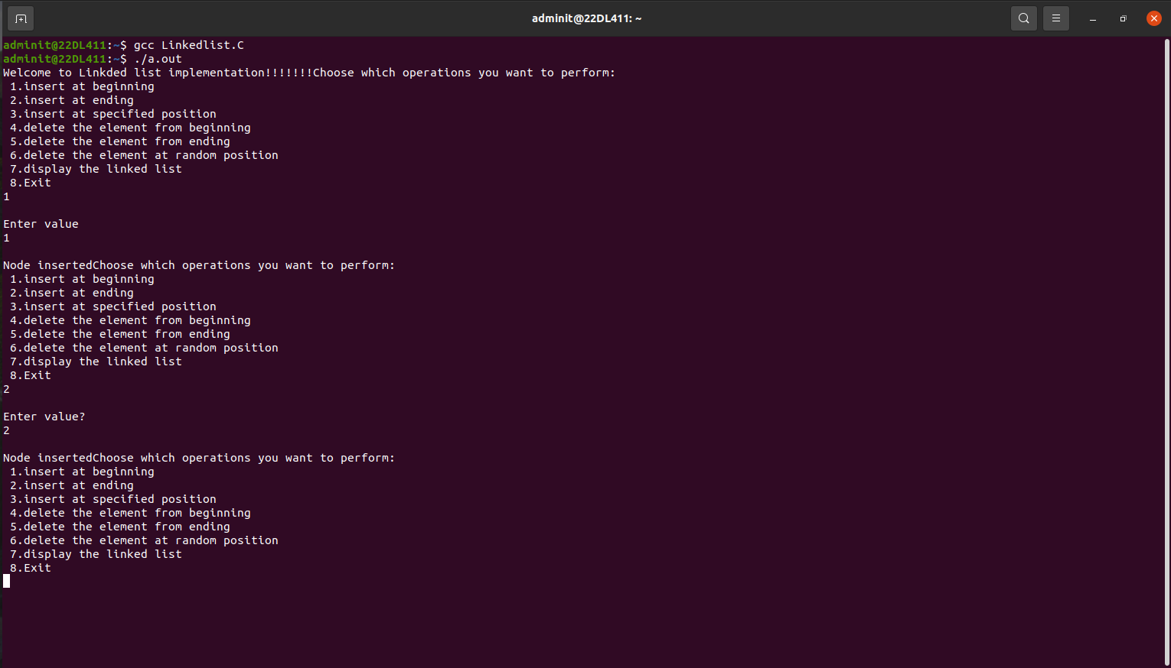

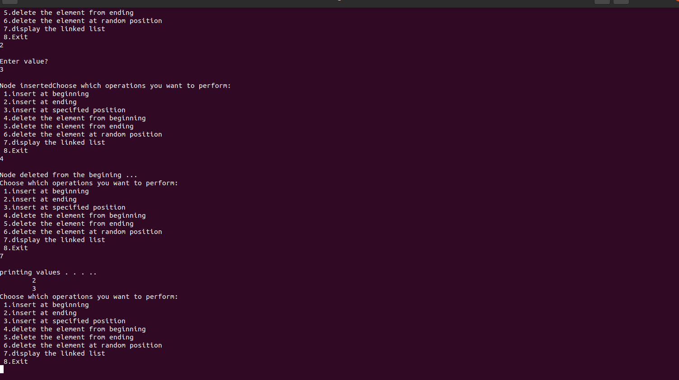

**Submitter Details -  
Name of Student: Yash.M.Dharamshi**

**Roll No.: 22  
Date of Performance: 12/09/2024**

**Date of Submission: 12/09/2024**